**Part 3**

**Step 1: Batch Prediction starts (Loading File & checking its architecture)** 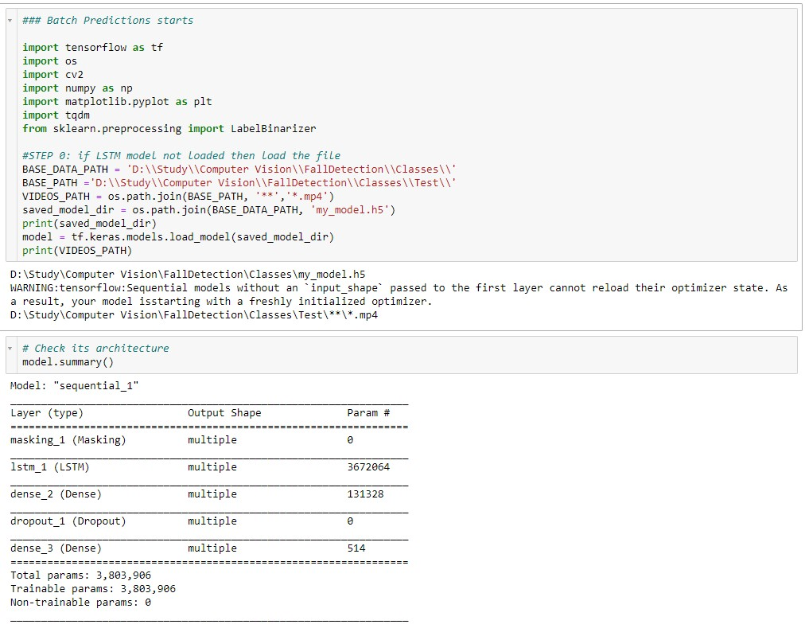

**Step 2: Defining function for Frame Generation** 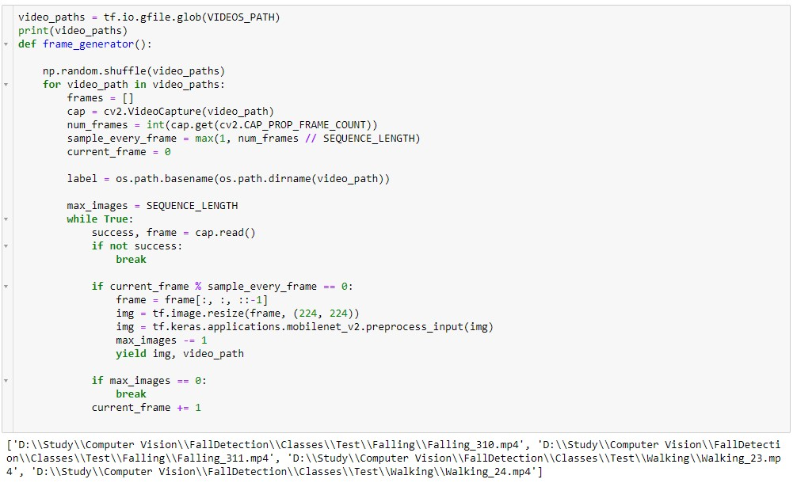

**Step 3: Calling Feature Extraction Model** 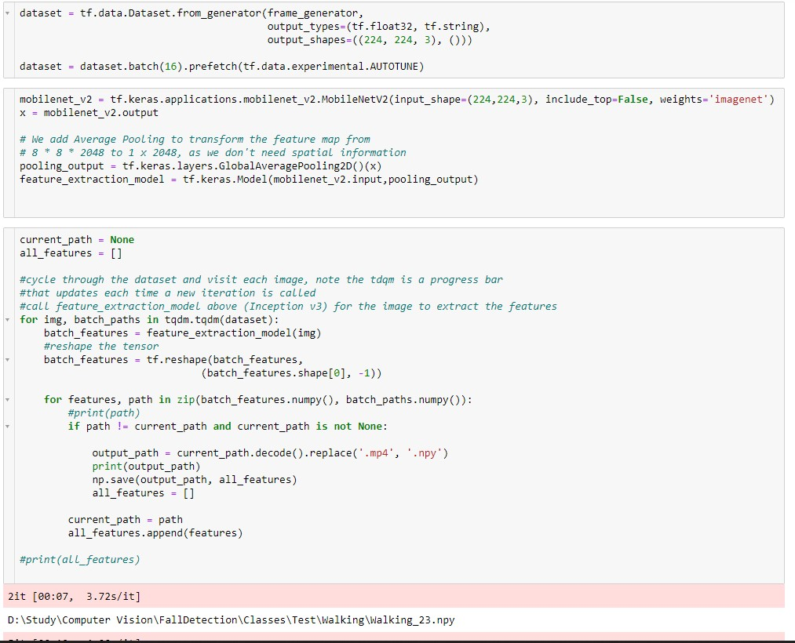

**Step 5 : Defining Function grabImagevideo to preprocess for MobileNet Feature Extraction** 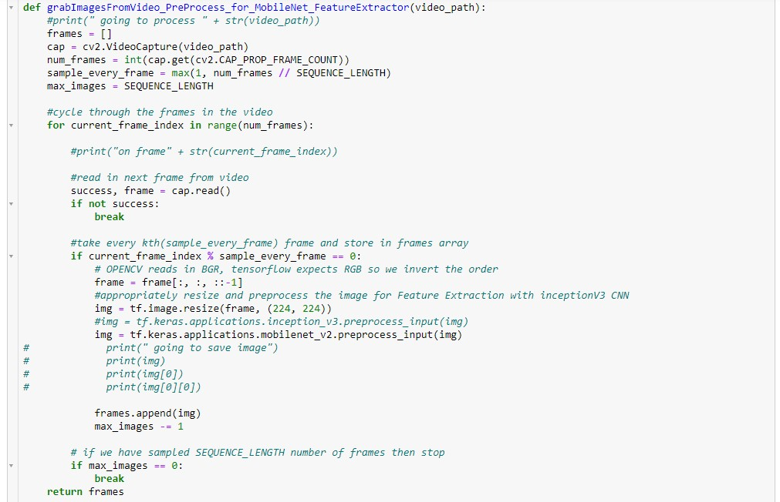

**Step 6: Processing Feature Extraction Model**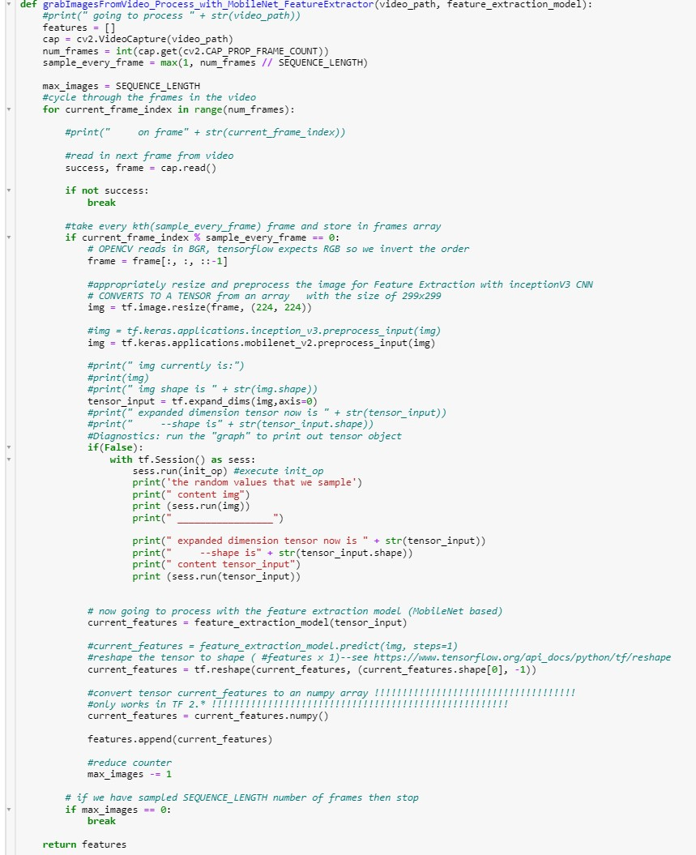

**Step 7: Performing Predictions using video data on LSTM model**